**Finding Lane Lines on the Road**

**Finding Lane Lines on the Road**

The goals / steps of this project are the following:

* Make a pipeline that finds lane lines on the road
* Implement Canny Edge Detection and Hough Space to identify lines
* Create lines extending from the car to visible distance by extrapolating lines using slope
* Get the model to be as robust as possible
* Reflect on your work in a written report

**Reflection**

**1. Describe your pipeline. As part of the description, explain how you modified the draw_lines() function.**

My pipelines consisted of 5 steps.

1. I first converted the images to grayscale to analyse dark and bright spots which help in identifying color changes and hence assisting in Canny Edge Detection
2. After which, I used a GaussianBlur for smoothing and then applied a Canny Edge algorithm to define the ‘edges’
3. To define the lane lines in the expected region of the image, I created a mask image with a four sided polygon which represents the desired location of the lane.
4. In this polygon, I ran the Hough space algorithm to define the lines or edges of the lanes
5. Overlaid these lines on the original image to convey that the lines obtained from Hough space actually lie on the lane

In order to draw a single line on the left and right lanes, I modified the draw_lines() function by

1. By finding the slopes for all lines and creating an array for it
2. Segregating the positive and negative slopes and finding the median so as to use this as the slope for the lines to be drawn
3. Extrapolating the left and right line, using the slope, to the bottom of the image
4. Extrapolating the lines to the top of visible distance
5. Drawing these lines on the mask image

Here are some images from the pipeline test_images used to detect the lines correctly

[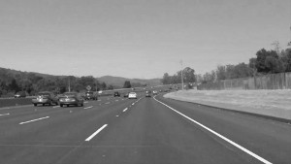](https://github.com/udacity/CarND-LaneLines-P1/blob/master/examples/grayscale.jpg)

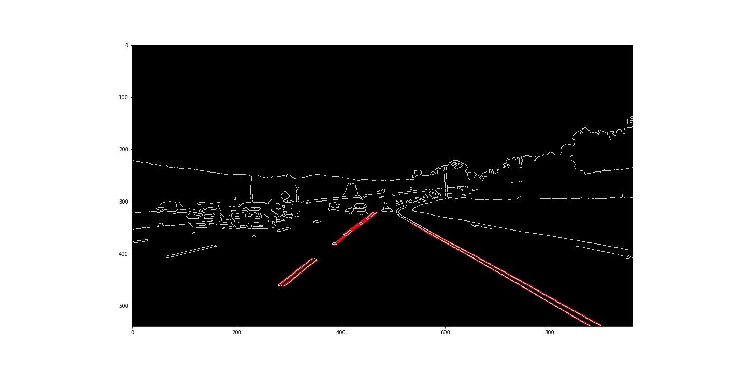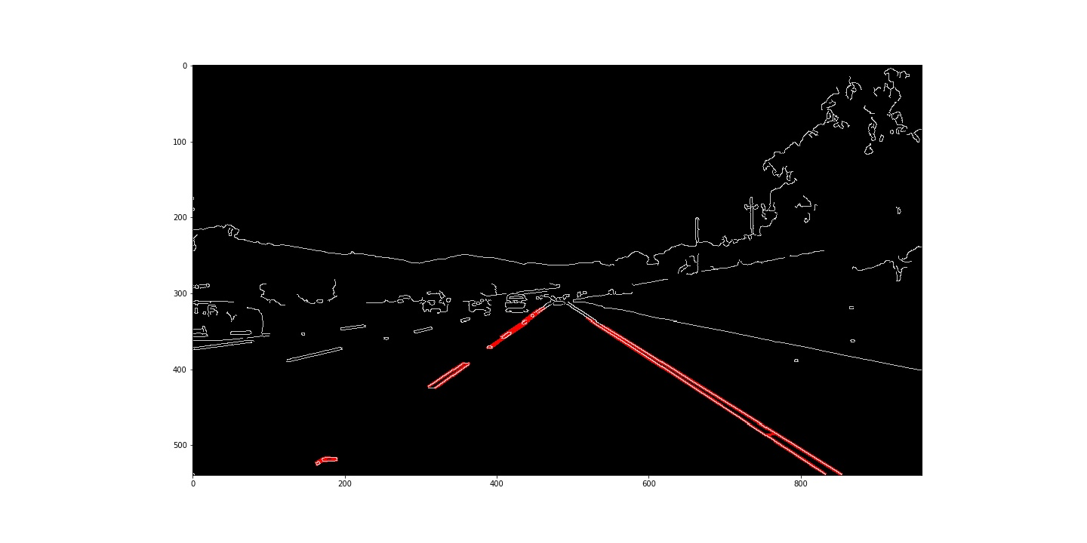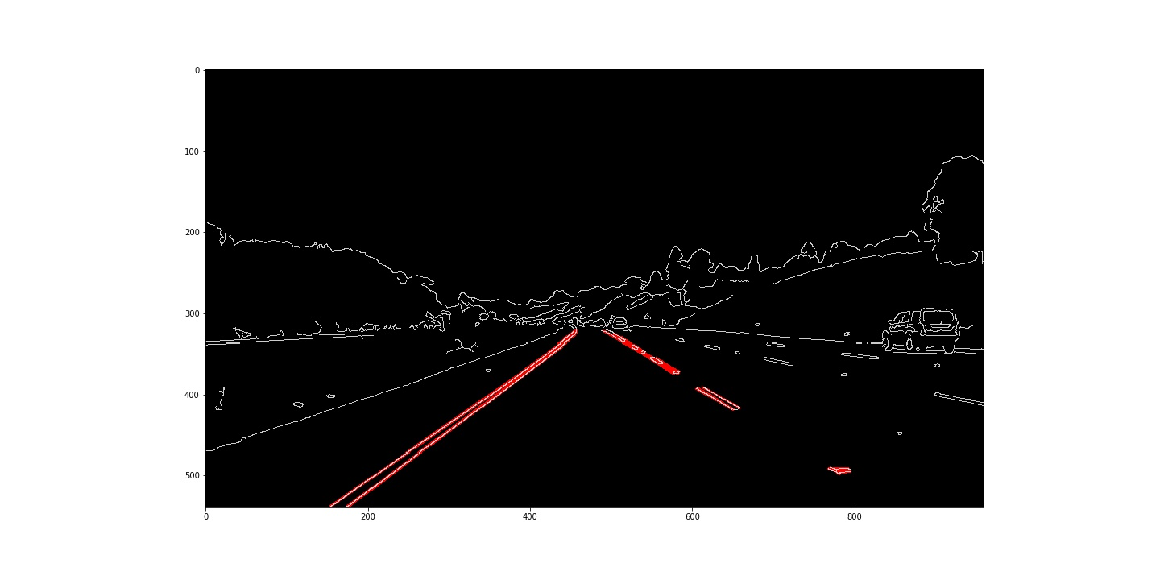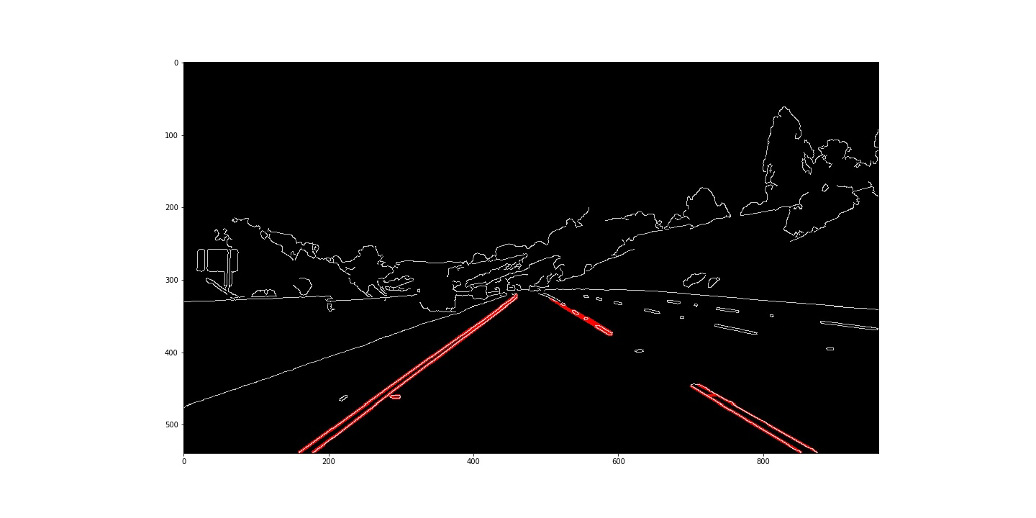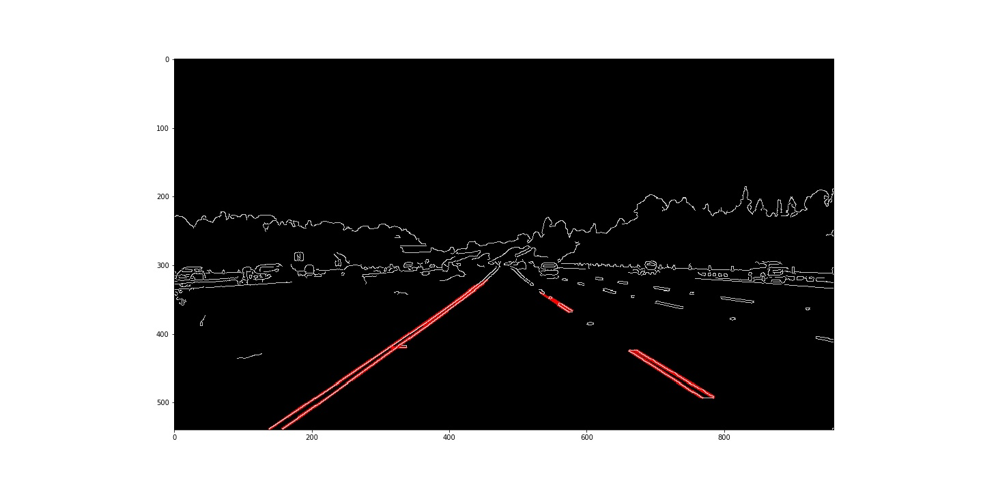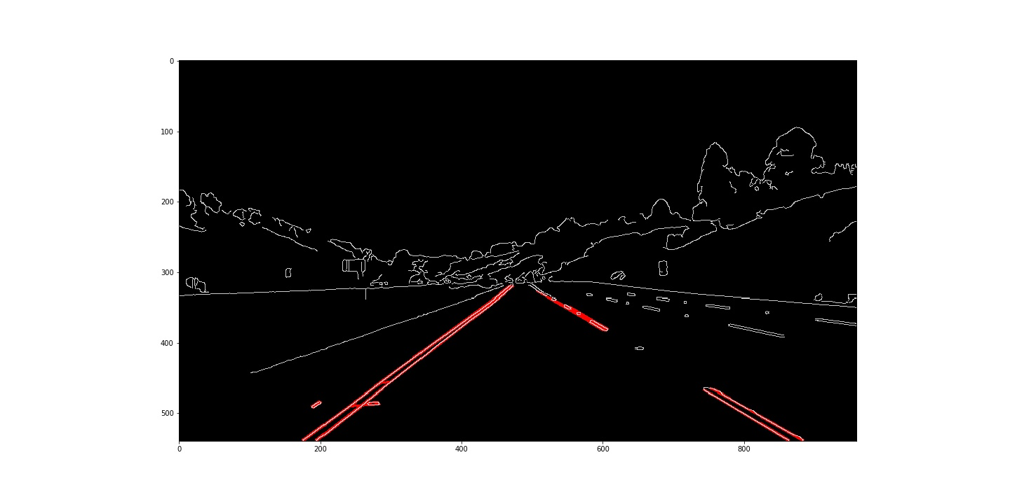

**2. Identify potential shortcomings with your current pipeline**

One potential shortcoming would be what would happen when the median of the slope does not give the correct slope for the lane thus causing the line to not appear in the right place

Another shortcoming could be the parameters changed to get the hough space to work for this video would not apply to others.

**3. Suggest possible improvements to your pipeline**

A possible improvement would be to the lines change rapidly from one frame to another in the video which could be smoothened in some way

Another potential improvement could be to calibrate the hough space parameters to meet the requirements for different images/videos